|  |  |  |
| --- | --- | --- |
|  | | 3 AUGUST 2025 |
| Business proposal | | |
|  |  | Prepared by: |
| ProSport Hub – Sports Equipment & Apparel Store  www.prosporthub.co.za  062 715 5517 | NURIYA AKBAR  nuriyaakbar1@gmail.com  065 786 7895 |

## **ProSport Hub – Sports Equipment & Apparel Store**

## **ProSport Hub Website Development Plan**

This document outlines the plan for developing a new website for ProSport Hub, a leading South African retailer of sports equipment, footwear, and team apparel. Established in 2012, ProSport Hub aims to empower individuals to achieve their best in sports and aspires to be Africa's most trusted supplier of sporting goods. The new website will target athletes, sports enthusiasts, schools, and sports clubs.

**Project Goals and Objectives:**

The primary goals for the new website are:

* Increase online sales by 30% within one year.
* Improve the user experience for browsing products and completing purchases.
* Foster brand loyalty through engaging and informative content, such as a blog.

Key Performance Indicators (KPIs) will be tracked to measure progress towards these goals, including:

1. **Online Sales Growth**

* Target: 30% increase in online sales during 12 months.
* Metric: Monthly revenue from the online sales (tracked via e-commerce dashboard).

1. **Conversion Rate**

* Target: Improve from current baseline (e.g., 1.5%) to at least 3% within 6 months.
* Metric: % of website visitors completing a purchase.

1. **Customer Retention / Repeat Purchases**

* Target: At least 25% of customers make a repeat purchase during the 6 month period.
* Metric: Customer purchase frequency (via CRM/e-commerce tracking).

1. **User Engagement**

* Target: Average session duration >3 minutes, with at least 5 pages viewed per session.
* Metric: Google Analytics user engagement reports.

1. **Mobile Responsiveness**

* Target: Bounce rate on mobile reduced by 20% within 6 months.
* Metric: Bounce rate segmented by device.

6. **Customer Satisfaction**

* Target: Achieve a Customer Satisfaction Score (CSAT) of 80%+ on post-purchase surveys.
* Metric: Feedback surveys / Net Promoter Score (NPS).

KPIs are essential to measure online sales, engagement, and retention (Marr, 2015).

E-commerce growth strategies often target conversion and mobile responsiveness (Laudon and Traver, 2022).

Digital marketing and SEO integration play a key role in website performance (Chaffey and Ellis-Chadwick, 2019).

A clear budget allocation improves financial planning for e-commerce projects (Shopify, 2023).

REFINED BUDGET BREAKDOWN:

|  |
| --- |
| BUDGET BREAKDOWN |
| | Category | Details | Estimated Cost (ZAR) | | --- | --- | --- | | Website Design & Development | UI/UX design, front-end & back-end dev, CMS integration | R 45,000 | | E-Commerce Setup | Product catalogue, cart & checkout system, payment gateway | R 20,000 | | Custom Features | Jersey customization tool, product filtering | R 15,000 | | Content Creation | Copywriting, product photography, blog setup | R 10,000 | | Hosting & Domain | 12 months premium hosting + domain renewal | R 6,000 | | SEO & Digital Marketing Setup | On-page SEO, Google Analytics, social media integration | R 8,000 | | Maintenance & Support | Security updates, bug fixes, backups (12 months) | R 12,000 | | Contingency (10%) | For unforeseen costs | R 11,600 | | Total Estimated Budget |  | R 127,600 | |

**Current Website Assessment:**

ProSport Hub currently benefits from a strong social media presence and good brand awareness. However, the current website has some limitations:

* Outdated visual design.
* Suboptimal performance on mobile devices.
* Confusing navigation.

To address these issues, the new website will feature:

* A contemporary and appealing interface.
* A responsive design that loads quickly on mobile devices.
* A streamlined and intuitive shopping process.

**Proposed Features and Functionality:**

The website will include the following features:

* **Homepage:** Featuring highlighted products and current special offers.
* **Product Catalog:** With comprehensive filtering options (by sport, brand, price range, etc.).
* **Jersey Customization Tool:** Allowing customers to personalize team apparel.
* **Informational Pages:** Including "Contact Us" and "About Us" sections

**4.** SITEMAP AND WIREFRAMES OF THE STRUCTURES

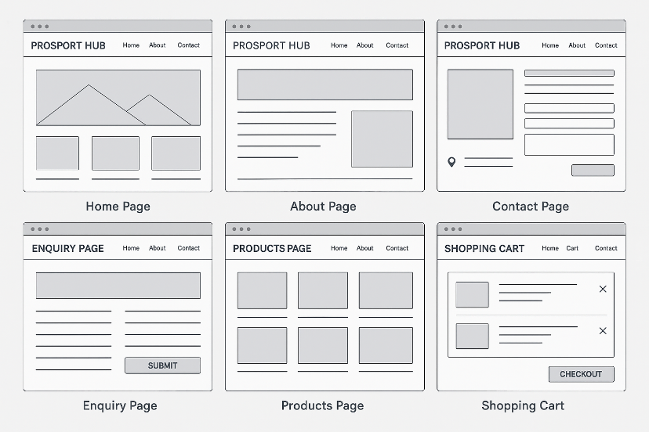

REFERENCES:

Chaffey, D. and Ellis-Chadwick, F., 2019. *Digital marketing*. 7th ed. Harlow: Pearson Education.

Kotler, P., Keller, K.L., Brady, M., Goodman, M. and Hansen, T., 2019. *Marketing management*. 4th European ed. Harlow: Pearson.

Laudon, K.C. and Traver, C.G., 2022. *E-commerce 2022: business, technology, society*. 17th ed. Harlow: Pearson.

Marr, B., 2015. *Key performance indicators (KPIs): the 75 measures every manager needs to know*. Harlow: Pearson Education.

Wix.com, 2023. *The ultimate guide to eCommerce KPIs*. [online] Available at: https://www.wix.com/blog/ecommerce-kpis [Accessed 28 September 2025].

Shopify, 2023. *How to budget for an eCommerce website*. [online] Available at: https://www.shopify.com/blog/ecommerce-budget [Accessed 28 September 2025].